**HIGHER DISTINCTION ASSIGNMENT PROJECT**

1. **A simple query of a single table:**

List Book IDs, Book Names, Price in AUD, Genre IDs, Author IDs from the book_collection table, who has a price greater than or equal to 25 and whose stock is more than or equal to 20. Finally, order the result by Book Name in ascending order.

**Query Output Table:**

1. **A query which uses natural join**

List all book IDs, Book Names, Author IDs, Author Names, their price in AUD, from Book Collection table using natural join, whose Author's ID is between

10 and 20 and order the result by Author Name in descending order.

**Output Query Table:**

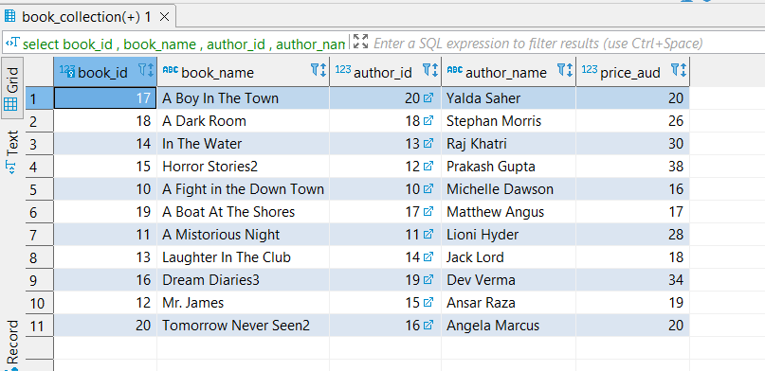

List Book IDs, Book Names, Author IDs, Author Names using the cross product and list all the authors whose name starts with M and then order the query by price in ascending order.

**3.The cross product equivalent to the "natural join" query above.**

**Query Output Table:**

**4.A query involving a “Group by”, perhaps also with a “HAVING”.**

List Purchase IDs, order date, price, discount, net price of orders(net price = price* quantity *(1-discount)), employee names from tables Purchase Information. Employee Information.

Use group by along with having condition. Display the above list whose order month is august and order by order date in ascending order.

**Query Output Table:**

**5. A query which uses a sub query.**

List all the Book names, Prices of books, and Genre IDs from the Book Collection table. It contains a sub-query that filters and extracts books from the list of books with minimum price and these books must belong to Genre Id 5.

**Query Output Table:**

**6.A cross product which cannot be implemented using the words “natural join” (e.g. self join).**

List all the employees, their position, date of hire and these employees should report to manager from Employee Information table using self join.

**Query Output Table:**

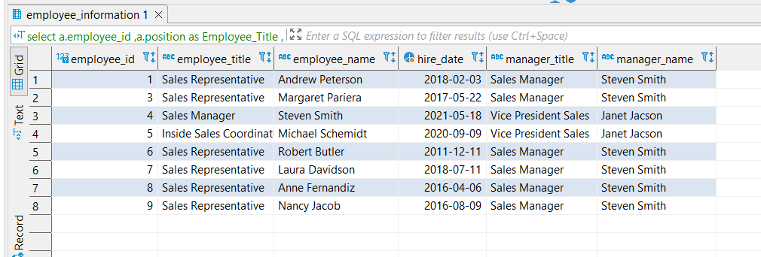

**ANSWERS**

1. **A simple query of a single table:**

**Query:**

select Book_Id, Book_Name

, price_aud,Genre_Id

, Author_Id

from book_collection

where in_stock >=20 and price_aud >=25

order by book_name asc;

**2.A query which uses natural join**

**Query:**

select book_id

, book_name

, author_id

, author_name

, price_aud

from book_collection natural join author_details

where author_id between 10 and 20

order by author_name desc;

**3.The cross product equivalent to the "natural join" query above.**

**Query:**

**select** Book_Collection.book_id

, Book_Collection.book_name

, Author_Details.author_id

, Author_Details.author_name

,Book_Collection.price_aud

**from** Book_Collection, Author_Details

**where** Author_Details.author_id = Book_Collection.author_id

**and** author_name **like** 'M%'

**order** **by** price_aud **asc**;

**4.A query involving a “Group by”, perhaps also with a “HAVING”.**

**Query:**

select Purchase_Information.purchase_id

,Purchase_Information.Date_Order

,Purchase_Information.price

,Purchase_Information.quantity

,Purchase_Information.discount

,Purchase_Information.quantity *(1-Purchase_Information.discount)*Purchase_Information.price as Net_Price

,Employee_Information.employee_name

from Purchase_Information inner join Employee_Information on Purchase_Information.employee_id = Employee_Information.employee_id

group by Purchase_Information.purchase_id ,Employee_Information.employee_name

having Extract('month' from date_order::date) = 08

order by purchase_Information.Date_Order asc;

**5. A query which uses a sub query.**

**Query:**

select book_name

, price_aud

, genre_id

from book_collection

where genre_id =5

and price_aud >=(

select min(price_aud)

from book_collection

where genre_id =5);

**6. A cross product which cannot be implemented using the words “natural join” (e.g. self join)**

**Query:**

select a.employee_id

,a.position as Employee_Title

,a.employee_name as Employee_Name

,a.Date_Hire as Hire_Date

, b.position as Manager_Title

, b.employee_name as Manager_Name

from employee_information as a , employee_information as b

where a.report_to_manager=b.employee_id;

**ADDITIONAL TASK**

**1.CUSTOMER_INFORMATION QUERY AND TABLE**

select * from customer_information;

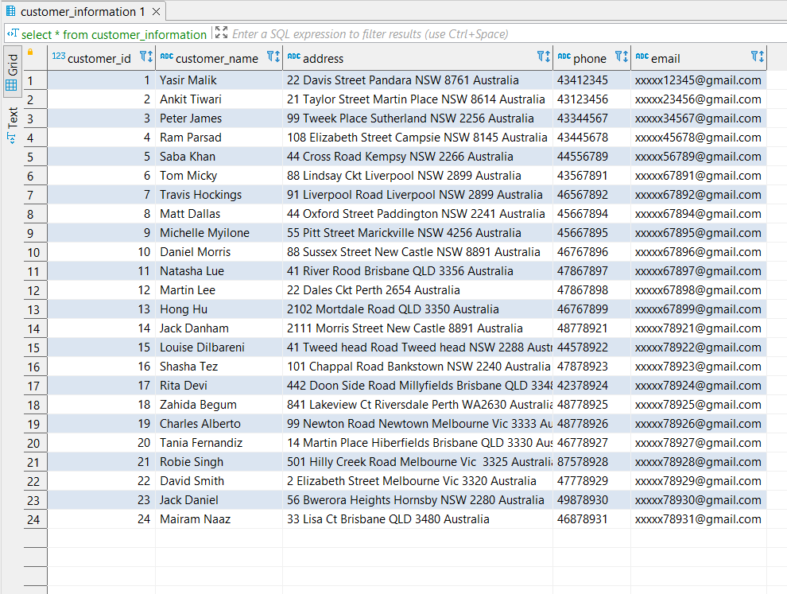

**2.QUERY TO INSERT A NEW ROW ENTRY INTO CUSTOMER_INFORMATION TABLE.**

**Query:**

insert into Customer_Information values(25, 'Teagen Lioni', '65 Lakemba Ct Sydney NSW 2280 Australia', 0468789332, 'xxxxx93321@gmail.com');

**TABLE OUTPUT:**

**3.QUERY TO UPDATE PHONE NUMBER IN CUSTOMER INFORMATION TABLE.**

**Query:**

update customer_information set phone=0468789112 where customer_id=25;

**OUTPUT:**

**4.DELETE STATEMENT TO DELETE AN ENTRY FROM TABLE.**

**Query:**

Delete from Customer_Information where customer_id=25;

**OUTPUT:**

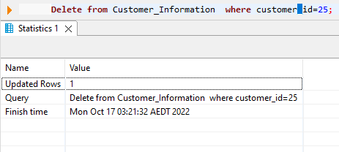

**ON DELETE CASCADE QUERY**

**5.APPLYING ON DELETE CASCADE CONSTRAINT ON BOOK_GENRES**

**QUERY**

**create** **table** Book_Collection

(

Book_Id **smallint**,

Book_Name **character** **varying** **not** **null**,

Genre_Id **integer**,

Author_Id **integer**,

Publisher_Id **integer**,

Price_AUD **integer**,

In_Stock **integer**,

**constraint** Book_Collectionpk **primary** **key** (Book_Id),

**constraint Book_Collectionfk_Book_Genres foreign key (Genre_Id) references Book_Genres on delete cascade,**

**constraint** Book_Collectionfk_Author_Details **foreign** **key** (Author_Id) **references** Author_Details,

**constraint** Book_Collectionfk_Book_Publisher **foreign** **key** (Publisher_Id) **references** Book_Publisher,

**constraint** unq_Book_Collection_book_name **unique** (book_name)

);

**OUTPUT TABLE OF BOOK_COLLECTION**

**(5.1).QUERY TO EXECUTE ON DELETE CASCADE**

**Comment: Book_Genre is Parent here and Book_Collection is Child**

**Query:**

**delete** **from** book_genres **where** genre_id  =1;

**OUTPUT FOR ON DELETE CASCADE ON BOOK_GENRE**

**6.APPLYING ON DELETE RESTRICT ON CUSTOMER_INFORMATION**

**Query:**

**create** **table** Purchase_Information

(

Purchase_Id **integer**,

Book_Id **integer**,

Price **integer**,

Quantity **integer**,

Discount **float**,

Customer_Id **integer**,

Employee_Id **integer**,

Date_Order **Date**,

Date_Shipped **character** **varying**,

Shipping_Address **character** **varying**,

**constraint** Purchase_Informationpk **primary** **key** (Purchase_Id),

**constraint** Purchase_Informationfk_Book_Collection **foreign** **key** (Book_Id) **references** Book_Collection,

**constraint** Purchase_Information_Price **check** (Price > 0),

**constraint** Book_Purchasefk_Customer_Information **foreign** **key** (Customer_Id) **references** Customer_Information **on** **delete** **restrict**,

**constraint** Book_Purchasefk_Employee_Information **foreign** **key** (Employee_Id) **references** Employee_Information

);

**OUTPUT TABLE FOR CUSTOMER_INFORMATION**

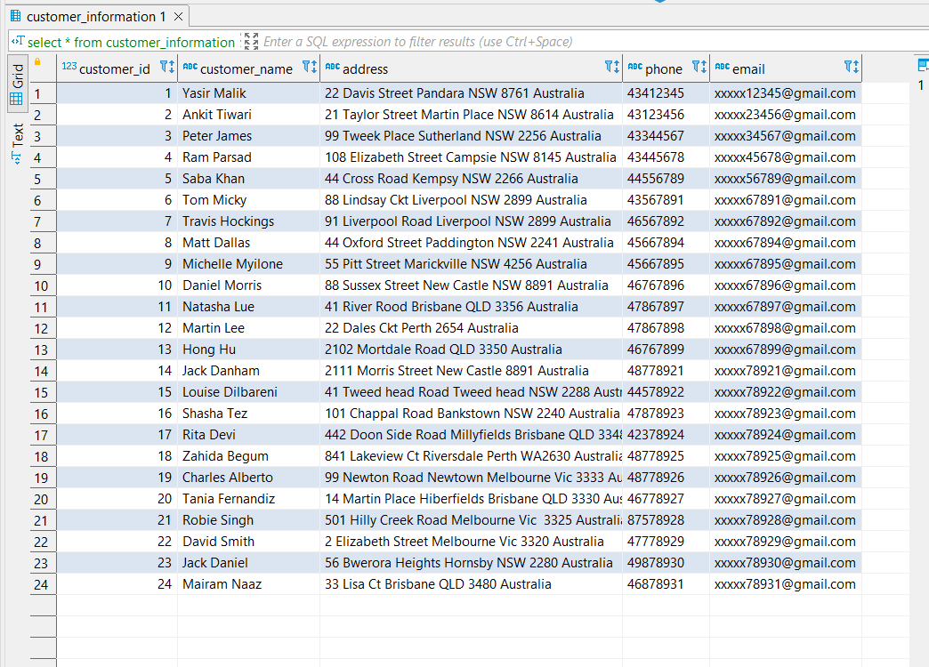

**OUTPUT TABLE FOR PURCHASE_INFORMATION**

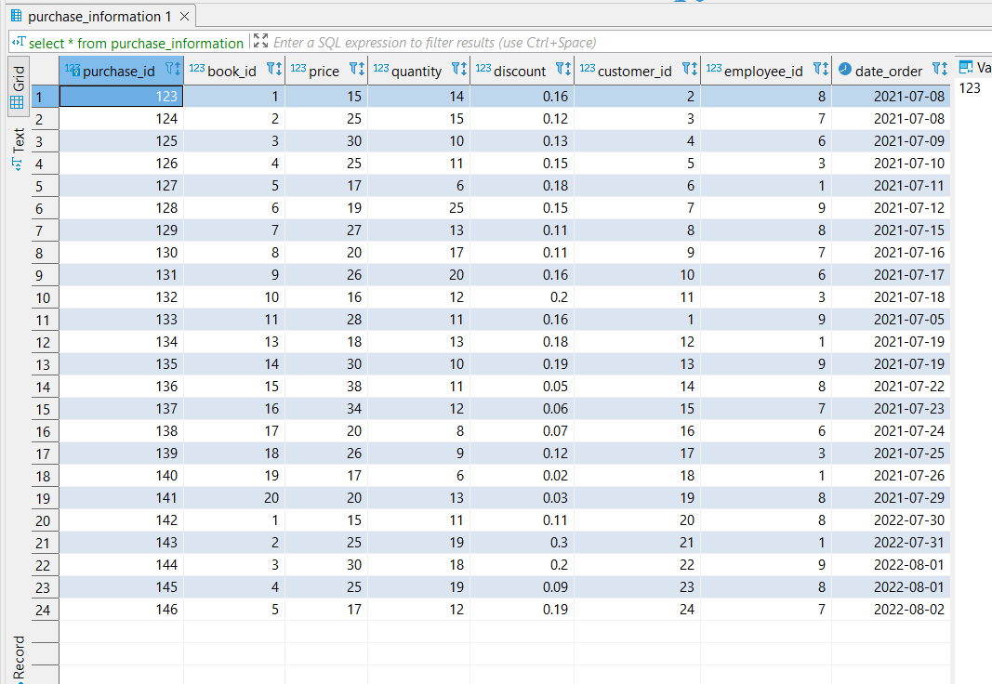

**(6.1).QUERY OF ON DELETE RESTRICT ON CUSTOMER_INFORMATION**

**QUERY:**

**delete** **from** customer_information

**where** customer_id =24;

**OUTPUT OF ON DELETE RESTRICT ON CUSTOMER_INFORMATION**

**REFERENCES :**

**1.** [Booktopia - Books, Online Books, #1 Australian online bookstore, Buy Discount Books, eBooks and DVDs from Australia and the world.](https://www.booktopia.com.au/?msclkid=f65fe960552c172165c58a2881bd3795&utm_source=bing&utm_medium=cpc&utm_campaign=Booktopia%20-%20AU%20-%20Search%20-%20Competitor%20(Exact,%20Phrase%20%2B%20Broad)&utm_term=amazons%20books&utm_content=Amazon)

**2.** [Book Depository: Free delivery worldwide on over 20 million books](https://www.bookdepository.com/?utm_source=Affiliate_AU&utm_medium=Affiliate_Marketing&utm_campaign=177157%20&utm_term=httpwwwfindercomau&awc=10920_1665719740_da97de068378e01b3b42330b853e9fe2)

**3.** [Books | Online Bookshop | QBD](https://www.qbd.com.au/?cfclick=ddaeecbc078044dfbe6c571fab2b4e29)